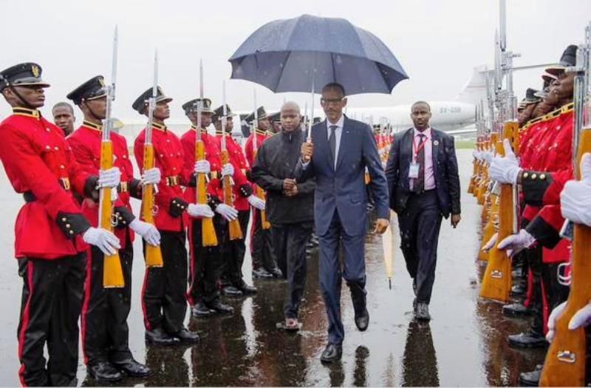

President Paul Kagame arrive today at the Tanzania airport

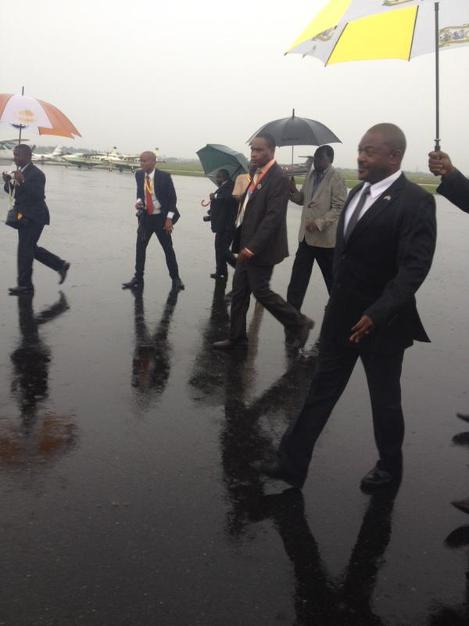

President of Burundi also arrived in Tanzania today